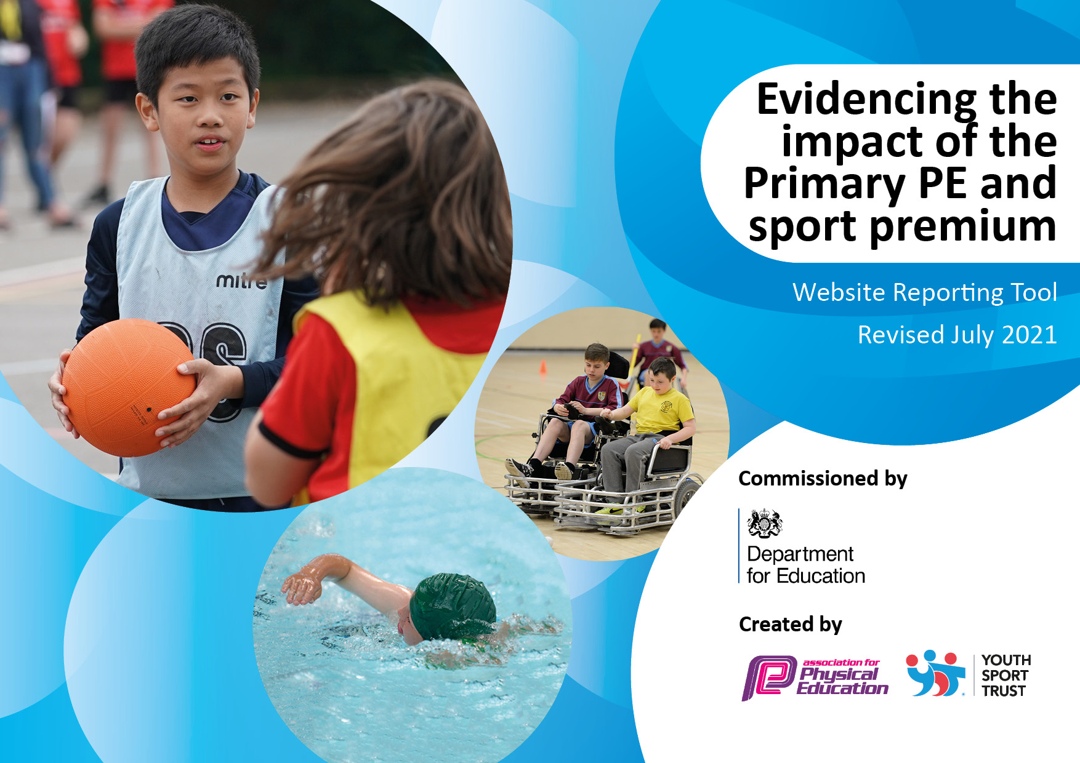
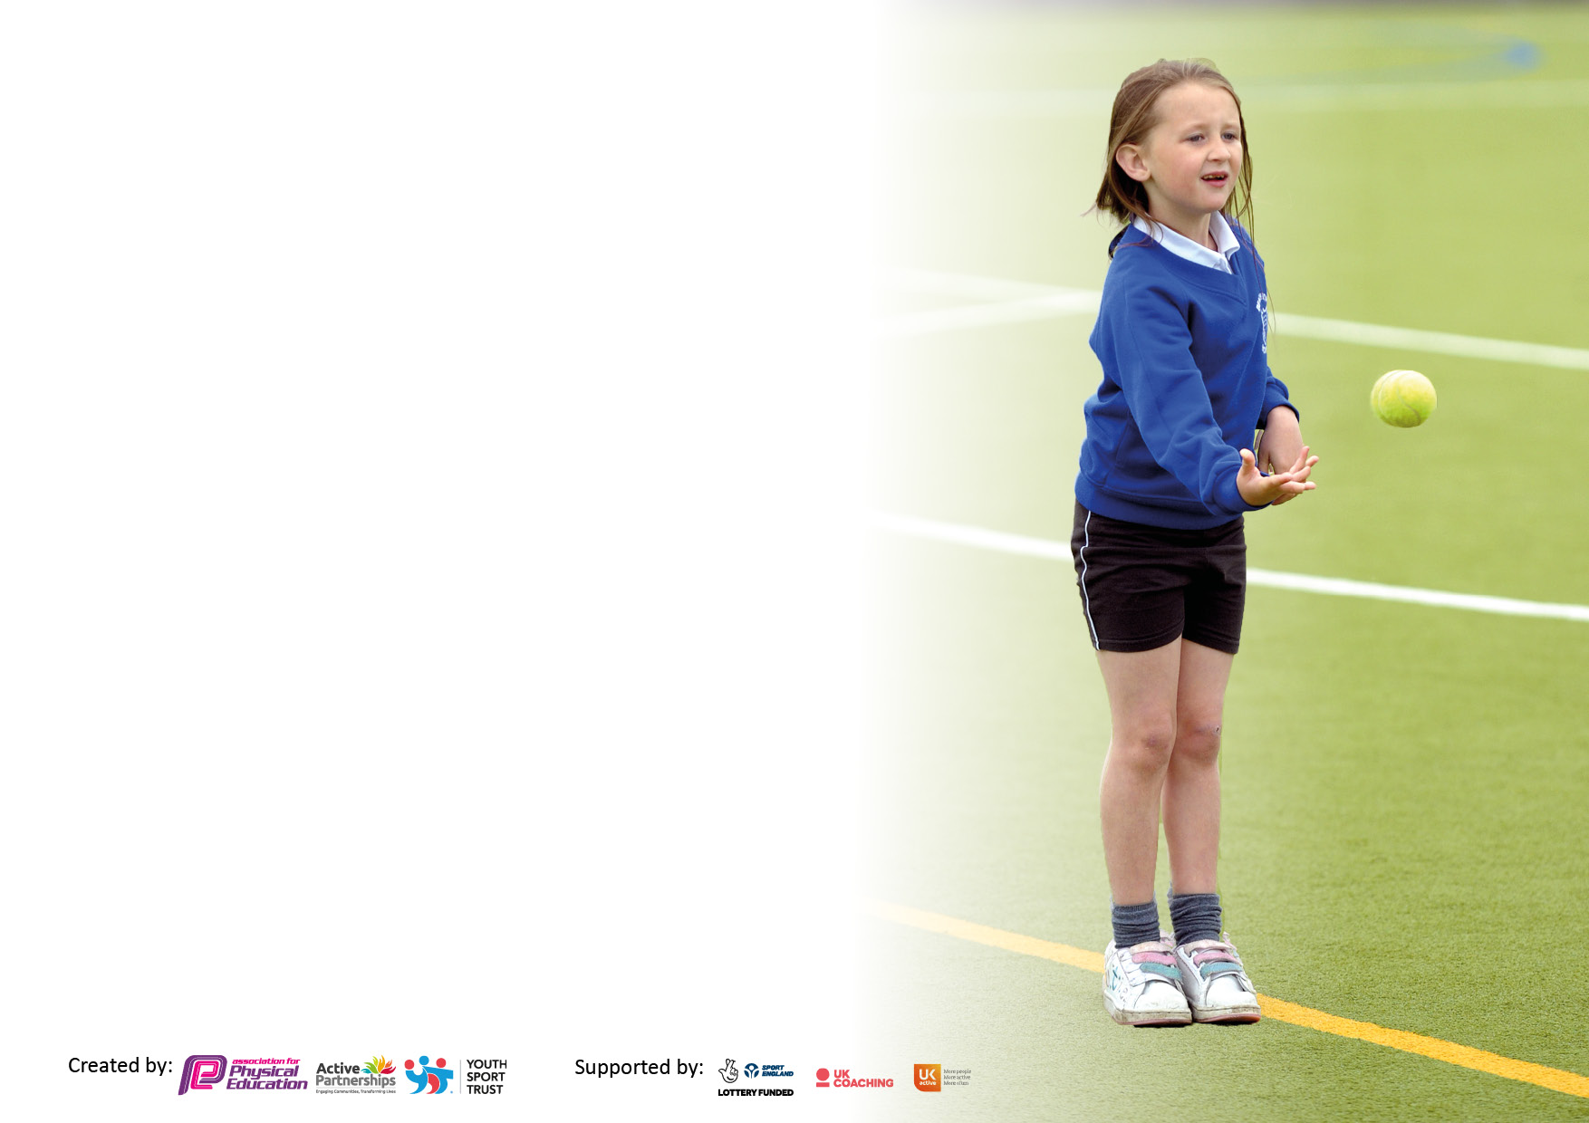

It is important that your grant is used effectively and based on school need. The Education Inspection Framework makes clear there will be a focus on ‘whether leaders and those responsible for governors all understand their respective roles and perform these in a way that enhances the effectiveness of the school’.

Under the Quality of Education Ofsted inspectors consider:
Intent - Curriculum design, coverage and appropriateness
Implementation - Curriculum delivery, Teaching (pedagogy) and Assessment
Impact - Attainment and progress

To assist schools with common transferable language this template has been developed to utilise the same three headings which should make your plans easily transferable between working documents.

Schools must use the funding to make additional and sustainable improvements to the quality of Physical Education, School Sport and Physical Activity (PESSPA) they offer. This means that you should use the Primary PE and sport premium to:

- Develop or add to the PESSPA activities that your school already offer
- Build capacity and capability within the school to ensure that improvements made now will benefit pupils joining the school in future years
- The Primary PE and sport premium should not be used to fund capital spend projects; the school’s budget should fund these.

Pleasevisitgov.ukfortherevisedDfEguidanceincludingthe5keyindicatorsacrosswhichschoolsshoulddemonstrate animprovement.Thisdocumentwillhelpyoutoreviewyourprovisionandtoreportyourspend.DfEencouragesschools to use this template as an effective way of meeting the reporting requirements of the Primary PE and sport premium.

We recommend you start by reflecting on the impact of current provision and reviewing the previous spend.

Schools are required to publish details of how they spend this funding, including any under-spend from 2019/2020, as well as on the impact it has on pupils’ PE and sport participation and attainment. All funding must be spent by 31st July 2022.

We recommend regularly updating the table and publishing it on your website throughout the year. This evidences your ongoing self-evaluation of how you are using the funding to secure maximum, sustainable impact. Final copy must be posted on your website by the end of the academic year and no later than the 31st July 2021. To see an example of how to complete the table please click HERE.
Created by: Supported by:

Details with regard to funding
Please complete the table below.

How much (if any) do you intend to carry over from this total fund into 2021/22? | £
Total amount allocated for 2021/22 | £
Total amount of funding for 2021/22. To be spent and reported on by 31st July 2022. | £16,580
Swimming Data
Please report on your Swimming Data below.

Meeting national curriculum requirements for swimming and water safety.

N.B. Complete this section to your best ability. For example you might have practised safe self-rescue techniques on dry land which you can then transfer to the pool when school swimming restarts.
Due to exceptional circumstances priority should be given to ensuring that pupils can perform safe self rescue even if they do not fully meet the first two requirements of the NC programme of study
What percentage of your current Year 6 cohort swim competently, confidently and proficiently over a distance of at least 25 metres?  N.B. Even though your pupils may swim in another year please report on their attainment on leaving primary school at the end of the summer term 2021.  Please see note above | 100%
What percentage of your current Year 6 cohort use a range of strokes effectively [for example, front crawl, backstroke and breaststroke]?  Please see note above | 100%
What percentage of your current Year 6 cohort perform safe self-rescue in different water-based situations? | 100 %
Schools can choose to use the Primary PE and sport premium to provide additional provision for swimming but this must be for activity over and above the national curriculum requirements. Have you used it in this way? | Yes/No

Action Plan and Budget Tracking
Capture your intended annual spend against the 5 key indicators. Clarify the success criteria and evidence of impact that you intend to measure to evaluate for pupils today and for the future.

Academic Year: 21/22 | Total fund allocated: | Date Updated:
Key indicator 1: The engagement of all pupils in regular physical activity – Chief Medical Officers guidelines recommend that primary school pupils undertake at least 30 minutes of physical activity a day in school |  |  |  | Percentage of total allocation:
 |  |  |  | %
Intent | Implementation |  | Impact
Your school focus should be clear what you want the pupils to know and be able to do and about  what they need to learn and to  consolidate through practice: | Make sure your actions to achieve are linked to your intentions: | Funding allocated: | Evidence of impact: what do pupils now know and what can they now do? What has changed?: | Sustainability and suggested next steps:
Ensure that playtimes are active and there are a range of resources available to support this  Ensure resources are stored in order to ensure ready access | Purchase of additional playground equipment plus accessible storage | £storage unit £180  £44 | Playtimes/ activities highlighted by pupils during discussions around behaviour policy and pupil questionnaires.  Revisit to assess impact next academic year. | Resources bought towards the end of the academic year so children will need training in September in how to use, what is available etc  Also, include briefing for Tas in September plus potentially training if available
To enable Forest School ethos and activity to continue into Class 2 because of noted benefits on both activity levels and also MH and wellbeing | Forest School sessions Class 2-  Training additional member of staff  Salaries of staffing to support  Purchase of additional resources | £905  £3400  £130 | Positive feedback from parents/ pupils (questionnaires).  High levels of engagement- especially from some lower attaining children | Member of staff trained plus commitment from SLT means this is now embedded into classroom routines.  Consider rolling out to KS2 if funding can be obtained.
Children have the opportunity to start the day in an active and fun way- part of extended provision | Early Bird PE starting at 8.30 am 2x sessions per term | Staff time- 6 hours x £30=£180 | Positive feedback in parent questionnaires  High percentage of engagement from pupils  Opportunity for Sports Leaders to take on a role of responsibility | Would like to see this increase- more sessions- but staff workload is an issue. Sustainable at current levels- look at possible ways of making it less intense for individual staff? Poss buy in additional coaching eg from Shelly- Zumba lead
Children are encouraged to travel to school actively – bike sheds and scooter racks provided. | Living Streets Travel Tracker participation across school | Nothing this year | Bike sheds and scooter racks full during summer months especially | Install second scooter rack over summer.  Keep investigating possibility of walking bus from either Newbrough and/or Fourstones especially during October (Walk to school month)
Children in Early Years are actively engaged in outdoor learning; cost is not a barrier to them being properly equipped | Purchase of waterproofs across the Early years unit by school so that all children have access to high quality outdoor kit | £330 | New scheme: impact to be assessed | Budget for replacement waterproofs
Key indicator 2: The profile of PESSPA being raised across the school as a tool for whole school improvement |  |  |  | Percentage of total allocation:
 |  |  |  | %
Intent | Implementation |  | Impact
 | Funded after school Zumba for Y3-6 to allow access for all | Funding allocated: see below | See below | To continue
see above | Early Bird PE sessions for whole school- 2x sessions per term | £ see above | As above | As above
Children access different active opportunities in a range of disciplines | Dance performance at Hadrian’s Wall as part of celebration of 1900th anniversary | £transport: £150 | All able to access performance and took part enthusiastically | One off event
Children take an active role in promoting active play and PE amongst younger children | Playmakers training run in school for all Y5/6 pupils- funded by school | 36x £40= £1440 | Playmakers able and confident to support at sports day/ early bird PE etc- all gained medals and badges | Continue for 3 new Y5 in September  Allocate roles to existing playmakers in September

Key indicator 3: Increased confidence, knowledge and skills of all staff in teaching PE and sport |  |  |  | Percentage of total allocation:
 |  |  |  | %
Intent | Implementation |  | Impact
Staff knowledge and skills increased so that their confidence in teaching different sessions is then increased | Dance- demonstration lesson by secondary lead with training video enabling staff to develop skills and lead practices with children  Demonstration of different skills by sports coach with teaching points highlighted | Funding:  £150  £2900 |  | Sustainability and suggested
 |  |  |  | next steps:
 | Forest school training and implementation of Forest School sessions by second class | £ see above section
Key indicator 4: Broader experience of a range of sports and activities offered to all pupils |  |  |  | Percentage of total allocation:
Intent | Implementation |  | Impact
Your school focus should be clear | Make sure your actions to | Funding | Evidence of impact: what do | Sustainability and suggested
what you want the pupils to know | achieve are linked to your | allocated: | pupils now know and what | next steps:
and be able to do and about | intentions: |  | can they now do? What has
what they need to learn and to |  |  | changed?:
consolidate through practice:
All Y5/6 children will have the opportunity to take part in challenging outdoor education activities led by outside providers at least once in their UKS2 class | Subsidised residential for some children to enable participation in outdoor activities in Lake District (canoeing/ ghyll scrambling/ walk in open country) | £700 | Pupils have experienced canoeing and ghyll scrambling; they have experienced challenge and success with these 2 activities; they have visited a very different environment and become aware of the opportunities which exist there. They have also used OS maps and navigated around a short walk- consolidating classroom learning in geography | Investigate opportunities locally to: build on the positive experiences of outdoor activities  Widen these experiences to younger age groups  Review and retain information about the residential to repeat in 2 years’ time
Children should have the opportunity to take part in sports after school clubs without having to pay- which limits participation for some  Clubs should be designed to actively appeal to as wide a range of pupils as possible | Zumba offered free to all children  Sports club offered free to all children | £2766  £950 | Up to 24 children (from across a KS2 cohort of 32) accessed Zumba this year at one time or another  Up to 20 children accessed sports club this year | Continue to pay for the Zumba teacher  Continue to pay for sports club
Children should have access to a wide range of sports/ PE activity using appropriate equipment | Additional equipment purchased plus replacement equipment purchased plus storage re-organised | £670 + £180 | Fencing (Sports coach) added to range taught this year plus Floorhoc ( school staff).  Table trolleys purchased for hall to enable gymnastics to be taught more easily (cost not included) | Storage- so we know what we have and it is accessible- and training- so that all staff know how to use all equipment.
All children in KS2 are able to access swimming lessons without cost being an issue | Swimming bus and swimming lessons subsidised to enable all KS 2 children to participate in swimming lessons | £845 | All KS2 children attend swimming lessons and make good progress towar5ds end of key stage targets | Monitor new Y6 cohort carefully- may need additional input (high percentage vulnerable children who don’t have access to swimming out of school)
Clear long term plan ensures all classes have framework for planning and progression; sports coach integrates his teaching with our LTP | Time allocated for PE lead to refresh LT planning to include as wide a range of sports as possible | £100 supply cover | All areas of PE are timetabled in across year with clear focus on range to be taught | Check planning allows for progression of knowledge and skills; ensure all areas of PE are happening

Key indicator 5: Increased participation in competitive sport |  |  |  | Percentage of total allocation:
 |  |  |  | %
Intent | Implementation |  | Impact
Your school focus should be clear | Make sure your actions to | Funding | Evidence of impact: what do | Sustainability and suggested
what you want the pupils to know | achieve are linked to your | allocated: | pupils now know and what | next steps:
and be able to do and about | intentions: |  | can they now do? What has
what they need to learn and to |  |  | changed?:
consolidate through practice:
Children should have the opportunity to take part in intra and inter school competitions | Whole school sports day this year  No inter school competitions- COVID effect | £ |  | Focus for next year- meeting arranged in September

Signed off by
Head Teacher: | Jo Trotter
Date: | 25/7/22
Subject Leader:
Date:
Governor:
Date:

