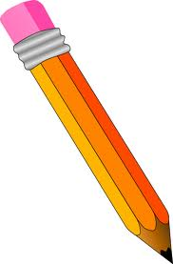

|  |  |
| --- | --- |
| A pencil | cubes |
| A felt tip pen | cubes |
| A maths book | cubes |
| A water bottle | cubes |
| A ruler | cubes |
| A table | cubes |
| A chair | cubes |
| A lunch box | cubes |
|  | cubes |
|  | cubes |