Choose one of the following and find as many examples as possible of trains in that genre:  eg how many books can you find where trains are mentioned?  Books, films, TV programmes, songs, toys  Choose one of your examples and explain it in more detail. You could use a poster, presentation, fact sheet, leaflet…. | Visit the website below and practice creating online circuits.  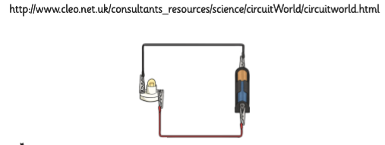 | Design a poster which explains the dangers of electricity.  Make it colourful and eye-catching!  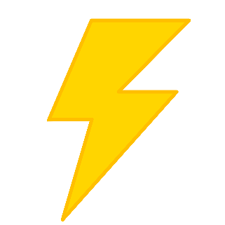
Choose a ‘gadget’ which you have in your house (eg mobile, computer or even the fridge).  Research the history of your gadget- find out who invented it, when, how it has changed over time, what people did before it was invented. Present your findings as a report or as an illustrated timeline. | Energy and Engineers  Year 5 and 6 Homework  Autumn 1  2018 | Complete the timetable problems which you will be given.  Think about the poem ‘Night mail’ by WH Auden which we have been studying in school.  Can you write your own ‘railway’ poem? Think about what you might see, where you might be going, how you might be feeling.
Most of our railways were constructed during the 19th Century- in Victorian times. But how else did people travel? What other modes of transport were invented?
Can you prepare a factsheet on Victorian transport OR make a model of a vehicle from Victorian times?
Write a story which features a journey. Who will your characters be? Where are they going and why? Will it be a scary story or an adventure? Maybe they are travelling into space?  Include description of characters and setting to engage your readers. | What inventions might engineers of the future come up with to make our lives easier or more fun, or to make getting around quicker?  Can you draw an annotated diagram or make a model of what you think the future might hold? | Homework is due in every THURSDAY please.  You need to complete one piece of homework each week The highlighted tasks are ‘musts’ but you can choose the others.

