349

**Can you work through the tricky Maths problems in your book?**

**Watch out for new challenges on our class 2 page**

* Measurement
* Shape
* Fractions

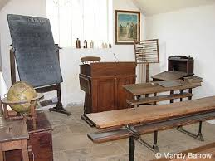

Can you research someone who lived in the Victorian times?

Write a fact file about them.

Make a quiz about the Victorians.

Don’t forget to write the answers down!

Use junk modelling to create a Victorian school. Can you label it?

**Class 2**

**‘Victorians’**

Design your own board game about the Victorians.

Imagine you lived in the Victorian times.

Write a diary entry about your day at school.

.

At the end of Spring term we were going to be researching Victorian transport in history and learning about then and now.

Can you research transport in the Victorian times?

What are the similarities and differences between cars now and then?

Did they have buses, taxis and bikes?

Record any information that you can find.

**Don’t forget to practise the times table you are working on at home!**

Class 2 have an Oxford Owl login! On this website there are lots of exciting e books to enjoy!

[www.oxfordowl.co.uk](http://www.oxfordowl.co.uk)

Click on ‘my class login’

Username: newbrough class 2

Password: NewbroughKS1

Here are some exciting links to practise our maths skills.

<https://www.topmarks.co.uk/maths-games/7-11-years/place-value>

<https://www.topmarks.co.uk/maths-games/5-7-years/addition-and-subtraction>