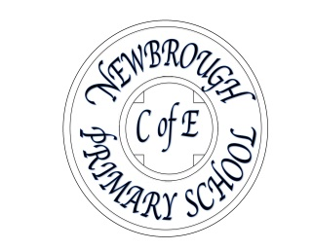

13/1/21

|  |
| --- |
| **Dear Parents,**  It hasn’t been the start of term that any of us would have wished for but hopefully, the situation will begin to improve soon. Thank you to all of you who are doing such an amazing job trying to juggle your children’s home learning with your own work and other commitments. Please get in touch if there is anything we can help with.  Thank you to the staff as well who are working hard to set work in Google classroom and respond to everything that is being sent in, as well as teaching in school.  I have been overwhelmed today by the unexpected generosity of someone, completely unconnected with the school, who has made us a donation of 5 brand new chrome books This person had seen a message from our Chair of Governors asking for donations of old laptops to support home learning. This is a truly amazing gesture which I know will help support some of our pupils. |
| **Celebration Assembly**  We are going to try and hold a short ‘virtual’ celebration assembly for the whole school on Friday this week.  The staff will be choosing their ‘Stars of the week’ for either their home learning or for their learning in school and awarding certificates. I will send you all a link/ instructions on how to join on Friday morning. The plan is that we will continue this weekly during lockdown but it will be dependent on us sorting out the technology and seeing if the broadband will support this. Please bear with us as there is likely to be a bit of a trial and error involved! |
| **Loan of Laptops**  Some of you mentioned that it would be helpful to borrow a school laptop or device to help with home learning.  Please get in contact if you would like to borrow something- either one of the donated chrome books or a school laptop. We will ask you to sign for them and obviously look after them with great care.  Please be aware that there is monitoring software installed on all of the devices and the school receives reports of which websites have been accessed plus any inappropriate search terms. |
| **Free Mobile data**  If you are accessing the internet via your mobile phone, then you may be eligible for free additional data to support your child’s home learning. A number of the network providers have signed up to this initiative.  If you would like to take advantage of this offer, then please send an email to admin@newbrough.northumberland.sch.uk with your mobile account holder’s name, mobile number beginning with 07, whether you pay monthly or pay as you go and your mobile network provider.  School can then apply for this on your behalf and let you know if you are eligible. |
| **Free School meals**  We are going to continue to supply vouchers to those of you whose children are eligible for a free school meal while the children are not in school. Vouchers will also be payable through February half term this year. |
| **And finally:**  If you have any question or concerns, please do get in touch.  If I don’t know there is a problem, I can’t sort it out!  Jo Trotter (Headteacher) |